CODE: SIMATS ENGINEERING
ASSESSMENT TOOL 1

COURSE NAME: COMPUTER ARCHITECTURE COURSE CSA1202

COURSE OUTCOME COVERED
CO1: Analyze the functional units of a computer system including CPU, memory, bus
structures, and I/O components by examining instruction execution cycles, addressing
modes, and performance metrics such as CPI, clock cycles, and benchmarking (BL4)
Assessment Tool Weightage: 40%

ANNEXURE A
APPLICATION BASED QUESTIONS

Code of Conduct:
I YAZHINI.EM/192511165 (Name / Reg No) certify that this submission is my original
work and that I have adhered to the guidelines specified for this assessment.
I understand that any violation of academic integrity rules will result in disciplinary
action.
ANNEXURE A

Question 1: Smart City Surveillance System
1. Introduction
- A smart city surveillance system consists of multiple cameras connected to a central processing unit for real-time monitoring.
- Cameras continuously generate video data, which is transferred through I/O devices to memory and processed by the CPU.
- During peak hours, the number of video streams increases, causing higher CPU workload, memory access delays, and increased I/O traffic.
- These limitations result in delayed threat detection and reduced system responsiveness.

2. Interaction Between CPU, Memory and I/O Devices
I/O Devices (Cameras)
- CCTV cameras act as input devices that continuously capture images and videos.
- The captured data is transferred through I/O controllers to the main memory.
- Multiple cameras sending data simultaneously increase I/O traffic.
Memory (RAM)
- RAM stores:
  - Incoming video frames
  - Processing instructions
  - Temporary results
- Since video processing requires large amounts of data, frequent memory access is required.
- Slow memory access causes the CPU to remain idle while waiting for data.

CPU
- The CPU performs:
  - Image processing
  - Object detection
  - Pattern recognition
  - Threat analysis
- The CPU continuously fetches instructions and data from memory.
- When the amount of incoming data exceeds CPU processing capacity, a processing bottleneck occurs.
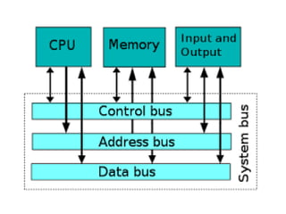

3. Causes of Delay During Peak Hours
1. Increased I/O Traffic
- More cameras generate more video frames.
- The I/O controller receives a large amount of data simultaneously.
- This increases transfer time and creates delays.
2. CPU Processing Overload
- Threat detection algorithms require complex calculations.
- The CPU requires more time to execute instructions.
- New incoming frames must wait for processing.
3. Memory Bottleneck
- Video frames are large in size.
- Frequent read and write operations increase memory access time.
- The CPU waits if memory cannot supply data quickly.
4. Communication Bus Limitation
- CPU, memory, and I/O devices communicate through buses.
- When multiple devices request access at the same time, bus contention occurs.
- This reduces the overall system performance.

4. Single Bus Structure
- In a single bus architecture, CPU, memory, and I/O devices share one common communication pathway.
- All data transfers occur through the same bus.
Working
- CPU requests data from memory.
- Memory transfers data through the common bus.
- I/O devices also use the same bus for communication.
Advantages
- Simple design.
- Less hardware requirement.
- Low implementation cost.
Limitations in Surveillance System
- Only one transfer can happen at a time.
- Cameras and CPU compete for bus access.
- High traffic causes waiting time.
- Not suitable for real-time video processing.

5. Multi Bus Structure
- Multi bus architecture uses separate buses for different communication tasks.
- Memory and I/O devices can communicate using separate paths.
Working
- CPU communicates with memory using the memory bus.
- Cameras communicate through an I/O bus.
- Multiple transfers can happen simultaneously.
Advantages
- Reduces bus congestion.
- Improves data transfer speed.
- Provides better CPU utilization.
- Suitable for high-speed surveillance systems.
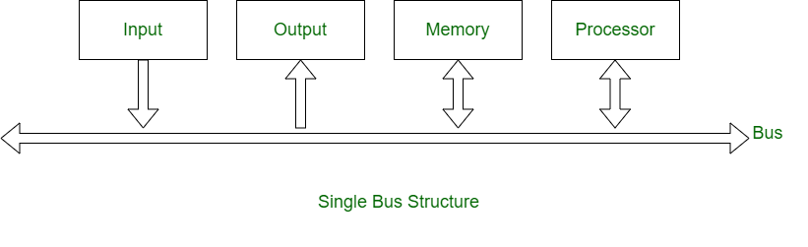

6. Comparison of Single Bus and Multi Bus
Single Bus | Multi Bus
Uses one common bus | Uses multiple buses
One transfer at a time | Multiple transfers possible
High congestion | Less congestion
Lower speed | Higher speed
Suitable for small systems | Suitable for real-time systems

7. Improvement of Instruction Execution Cycle
The CPU executes instructions using the following stages:
Fetch → Decode → Execute → Memory Access → Write Back
Fetch Stage
- CPU obtains instructions from memory.
- Delay occurs when memory response is slow.
Improvement:
- Use cache memory for faster instruction access.
Decode Stage
- Control unit interprets the instruction.
Improvement:
- Faster decoding hardware improves execution speed.
Execute Stage
- ALU performs required operations.
Improvement:
- Parallel processing and multiple execution units reduce processing time.
Memory Access Stage
- Data is read or written from memory.
Improvement:
- DMA allows cameras to transfer data directly to memory without continuous CPU involvement.

8. Performance Enhancement Techniques
Cache Memory
- Stores frequently accessed instructions and data.
- Reduces CPU waiting time.
DMA (Direct Memory Access)
- Transfers video data directly between cameras and memory.
- Reduces CPU workload.
Pipelining
- Allows multiple instructions to be processed at the same time.
- Increases instruction throughput.
Multi-Core Processors
- Different cores can process multiple camera feeds simultaneously
9. Conclusion
- The delay in smart city surveillance occurs due to increased communication between CPU, memory, and I/O devices.
- Single bus architecture creates congestion because all components share the same communication path.
- Multi bus architecture improves performance by allowing parallel data transfer.

Question 2: Real-Time Stock Trading Application
A real-time stock trading application executes millions of instructions per second, but users experience delays during high load. The processor has a high CPI due to frequent memory access and branch instructions. Analyze how the fetch–decode–execute cycle affects execution time and suggest architectural enhancements to reduce CPI and improve CPU performance.

1. Introduction
- A real-time stock trading application requires extremely fast processing because transactions must be completed within milliseconds.
- The processor executes millions of instructions per second to handle:
  - Stock price updates
  - Buy/sell orders
  - Market data analysis
  - Transaction verification
- During high market activity, users experience delays because the CPU requires more cycles to complete instructions.
- The main reasons for increased execution time are:
  - Frequent memory access
  - Branch instructions
  - High CPI (Cycles Per Instruction)

2. CPU Performance and CPI
- CPU performance depends on the number of clock cycles required to execute instructions.
- CPI (Cycles Per Instruction) represents the average number of clock cycles required for one instruction.
Formula:
$$CPU Execution Time=Instruction Count×CPI×Clock Cycle Time$$
- A lower CPI means faster instruction execution.
- A higher CPI increases execution time and causes transaction delays.

3. Effect of Fetch–Decode–Execute Cycle on Execution Time
The CPU executes every instruction using the following stages:
Fetch → Decode → Execute → Memory Access → Write Back
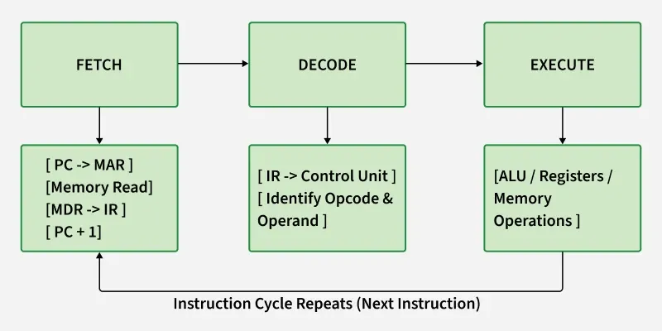

1. Fetch Stage
- The CPU fetches instructions from memory.
- In a stock trading application, thousands of instructions are executed continuously.
- If instructions are not available quickly, the CPU waits for memory.
Problem:
- Slow memory access increases CPU cycles.
Solution:
- Use cache memory to store frequently used instructions.
2. Decode Stage
- The Control Unit decodes the fetched instruction.
- It determines the operation that needs to be performed.
Example:
- Checking stock value
- Executing buy/sell commands
Problem:
- Complex instructions require additional decoding time.
Solution:
- Use efficient instruction decoding techniques.

3. Execute Stage
- The ALU performs calculations and logical operations.
Examples:
- Comparing stock prices
- Calculating profits
- Processing transactions
Problem:
- A large number of calculations increases CPU workload.
Solution:
- Use multiple execution units for parallel processing.

4. Memory Access Stage
- Data is read from or written to memory.
Examples:
- Accessing customer accounts
- Updating transaction records
Problem:
- Frequent memory access increases CPI.
Solution:
- Improve cache performance and memory hierarchy.

5. Write Back Stage
- The processed result is stored in registers or memory.
- Faster register access improves overall execution speed.

4. Reasons for High CPI in Stock Trading System
1. Frequent Memory Access
- Trading applications frequently access:
  - Market databases
  - User accounts
  - Transaction records
- Main memory access is slower than CPU operations.
Effect:
- CPU waits for data.
- Additional clock cycles are required.

2. Branch Instructions
- Trading applications contain many decision-making operations.
Example:
If stock price > limit
Execute Buy Order
Else
Reject Order
- Branch instructions change the normal instruction flow.
Effect:
- CPU may wait until the branch result is known.
- Causes pipeline stalls.

3. Cache Misses
- If required data is not available in cache:
  - CPU accesses slower main memory.
  - Execution time increases.

5. Architectural Enhancements to Reduce CPI
1. Cache Memory
- Cache is a high-speed memory placed between CPU and RAM.
- Frequently used data and instructions are stored in cache.
Benefits:
- Reduces memory access time.
- Decreases CPI.
- Improves transaction speed.

2. Instruction Pipelining
- Pipelining divides instruction execution into multiple stages.
- Multiple instructions are processed simultaneously.

Example:
Instruction 1 → Execute
Instruction 2 → Decode
Instruction 3 → Fetch
Benefits:
- Increases instruction throughput.
- Reduces idle CPU time.
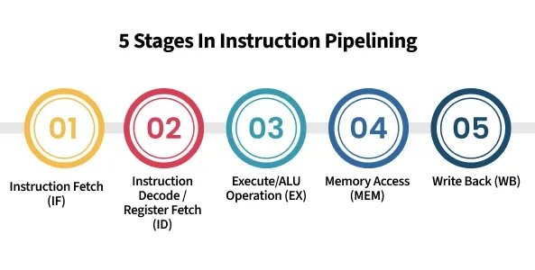

3. Branch Prediction
- Branch prediction predicts the result of a branch instruction before it is completed.
- The CPU continues execution without waiting.
Example:
- Predicts whether a stock price condition will be true.
- Loads the required instructions in advance.
Benefits:
- Reduces pipeline stalls.
- Improves execution speed.

4. Superscalar Architecture
- A superscalar processor can execute multiple instructions in one clock cycle.
- It uses multiple execution units.
Benefits:
- More instructions completed per cycle.
- Reduces overall processing time.

5. Out-of-Order Execution
- The CPU executes instructions whenever required resources are available.
- It does not always follow the original instruction order.
Benefits:
- Keeps CPU units busy.
- Improves performance.

6. Faster Memory Hierarchy
Improving memory speed reduces CPI.
Hierarchy:
Registers
↓
Cache Memory
↓
Main Memory
↓
Secondary Storage
- Frequently used trading data should be placed closer to the CPU.

7. Multicore Processing
- Multiple CPU cores can handle different tasks simultaneously.
Example:
- Core 1 → Market data processing
- Core 2 → Transaction verification
- Core 3 → User requests
Benefit:
- Improves performance during high load.

8. Comparison of Performance Improvements
Technique | Effect on CPU Performance
Cache Memory | Reduces memory access delay
Pipelining | Increases instruction throughput
Branch Prediction | Reduces branch delays
Superscalar Processing | Executes multiple instructions per cycle
Out-of-Order Execution | Improves CPU utilization
Multicore Processor | Enables parallel processing

9. Conclusion
- The delay in the stock trading application occurs because high CPI increases the number of clock cycles required to execute instructions.
- Frequent memory access and branch instructions cause pipeline stalls and increase execution time.
- Reducing CPI through cache memory, pipelining, branch prediction, superscalar execution, and multicore processors improves CPU performance.
- These architectural enhancements allow faster transaction processing and better response time during heavy market activity.
Question 3: 8086 Segmentation and Addressing Modes
A computing system uses an 8086 microprocessor with segmented memory for executing multiple programs simultaneously, but it faces issues like incorrect data access and stack overflow errors. Evaluate how segmentation works in 8086, analyze problems caused by improper segment handling, and explain how instruction execution and addressing modes ensure correct program execution.

1. Introduction
- The 8086 microprocessor uses a segmented memory architecture to access up to 1 MB of memory.
- Since the 8086 has a 16-bit address bus, it uses segment registers to generate 20-bit physical addresses.
- Memory is divided into different segments to organize programs and data.
- The main segments are:
  - Code Segment (CS)
  - Data Segment (DS)
  - Stack Segment (SS)
  - Extra Segment (ES)
- Proper segment management is necessary to avoid:
  - Incorrect data access
  - Stack overflow
  - Program execution errors

2. 8086 Memory Segmentation
- In 8086, memory is divided into logical sections called segments.
- Each segment can have a maximum size of 64 KB.
- A segment starts at an address defined by a segment register.
The physical address is calculated using:
Physical\ Address = Segment\ Address \times 10H + Offset\ Address

Example:
If:
- Segment address = 2000H
- Offset address = 1500H
Physical Address:
2000H × 10H + 1500H

= 20000H + 1500H

= 21500H

3. Segment Registers in 8086
1. Code Segment (CS)
- Stores the instructions of a program.
- The Instruction Pointer (IP) contains the offset address of the next instruction.
- CPU fetches instructions using:
Physical Address = CS × 10H + IP

2. Data Segment (DS)
- Stores program data such as:
  - Variables
  - Arrays
  - Constants
- Data is accessed using DS with offset values.
Example:
MOV AX, [2000H]
The CPU accesses data using:
DS × 10H + Offset

3. Stack Segment (SS)
- Stores temporary data:
  - Function calls
  - Return addresses
  - Local variables
- Uses:
  - Stack Pointer (SP)
  - Base Pointer (BP)
Example:
PUSH AX
POP BX

4. Extra Segment (ES)
- Used for additional data storage.
- Commonly used in string operations.

4. Segment Organization Diagram
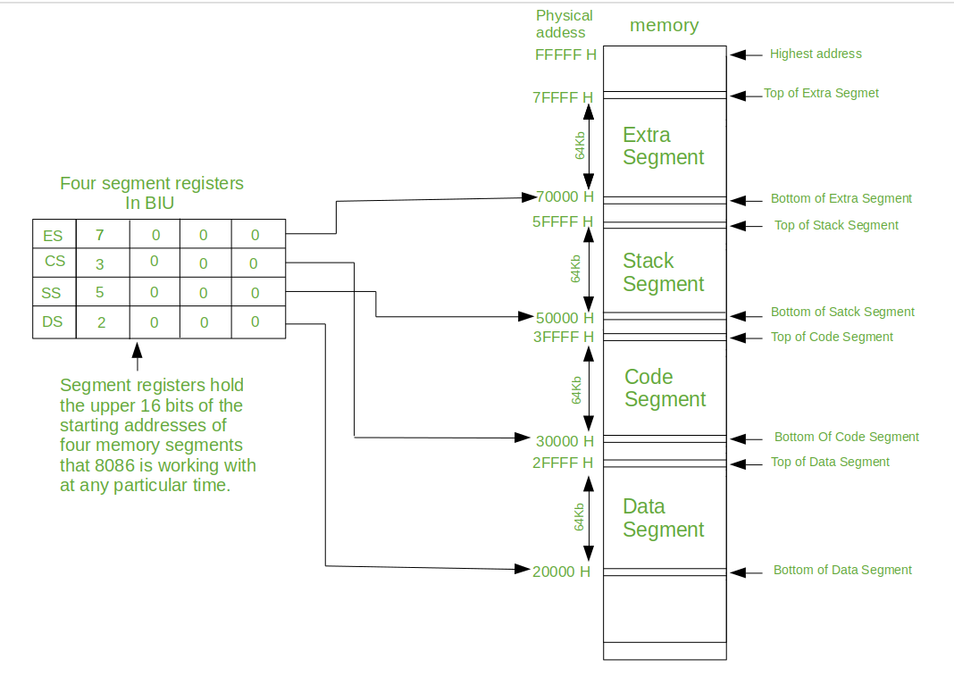

5. Problems Due to Improper Segment Handling
1. Incorrect Data Access
- If the Data Segment register (DS) contains the wrong value, the CPU accesses incorrect memory locations.
- This may result in:
  - Wrong data reading
  - Data corruption
  - Program failure
Example:
Correct:
DS = 3000H
Variable Address = 1000H
Physical Address = 31000H
Incorrect DS value accesses a different memory location.

2. Stack Overflow
- The stack has limited memory space.
- Excessive PUSH operations without POP operations increase stack usage.
Example:
PUSH AX
PUSH BX
PUSH CX
If the stack exceeds its allocated limit:
- Old data may be overwritten.
- Return addresses may be lost.
- Program execution may crash.

3. Code Segment Error
- If CS is incorrectly loaded:
  - CPU fetches wrong instructions.
  - Program executes unexpected operations.

6. Addressing Modes in 8086
Addressing modes define how the processor accesses operands.

1. Immediate Addressing Mode
- Data is directly provided in the instruction.
Example:
MOV AX, 1234H

2. Register Addressing Mode
- Operand is stored in a register.
Example:
MOV AX, BX

3. Direct Addressing Mode
- Memory address is directly specified.
Example:
MOV AX, [2000H]

4. Register Indirect Addressing Mode
- Register contains the memory address.
Example:
MOV AX, [BX]

5. Based Addressing Mode
- Base register is used with displacement.
Example:
MOV AX, [BX+10H]

7. Instruction Execution in 8086
The 8086 executes instructions using:
1. Fetch
- Instruction is fetched from Code Segment.
- CS and IP determine the instruction address.
2. Decode
- Control Unit interprets the instruction.
3. Execute
- ALU performs the operation.
4. Memory Access
- Data is accessed using DS or ES.
5. Stack Operations
- SS and SP manage stack data.

8. Correct Segment Handling Techniques
1. Initialize Segment Registers Properly
Example:
MOV AX, DATA
MOV DS, AX
- Loads correct data segment before accessing variables.

2. Manage Stack Carefully
- Initialize stack pointer correctly.
Example:
MOV AX, STACK
MOV SS, AX
MOV SP, 1000H
- Avoids stack overflow.

3. Use Correct Addressing Modes
- Correct addressing mode ensures correct memory access.
- Prevents accessing unwanted locations.

9. 8086 Assembly Program Example
Program: Add Two Numbers Stored in Data Segment
DATA SEGMENT
NUM1 DW 1234H
NUM2 DW 1111H
RESULT DW ?
DATA ENDS

CODE SEGMENT
ASSUME CS:CODE, DS:DATA

START:

MOV AX, DATA
MOV DS, AX

MOV AX, NUM1
ADD AX, NUM2

MOV RESULT, AX

MOV AH, 4CH
INT 21H

CODE ENDS
END START

10. Sample Output
Input Data:
NUM1 = 1234H
NUM2 = 1111H
Execution:
1234H + 1111H
Output:
RESULT = 2345H

11. Advantages of Segmentation
- Allows access to 1 MB memory.
- Separates program instructions and data.
- Supports multiple programs.
- Improves memory organization.
12. Conclusion
- The 8086 segmented memory architecture divides memory into code, data, stack, and extra segments.
- Correct segment initialization is necessary for proper instruction execution and data access.
- Incorrect segment values cause problems such as wrong data access and stack overflow.
- Proper use of segment registers, addressing modes, and instruction execution methods ensures reliable program execution.

